**Ashley Long – Researching Challenges in other Games – S191597**

**Research potential challenges for the game**

The outcome of this task is to research challenges that the game could present to the player to keep the game ***engaging*** and ***enjoyable.***

To research challenges that the team could bring forth into our own game, I have been tasked with researching games which have a one touch mechanic. I wanted to analyse what challenges these games brought to the player, and how those challenges kept the game engaging and enjoyable for the player.

One Tap Hero

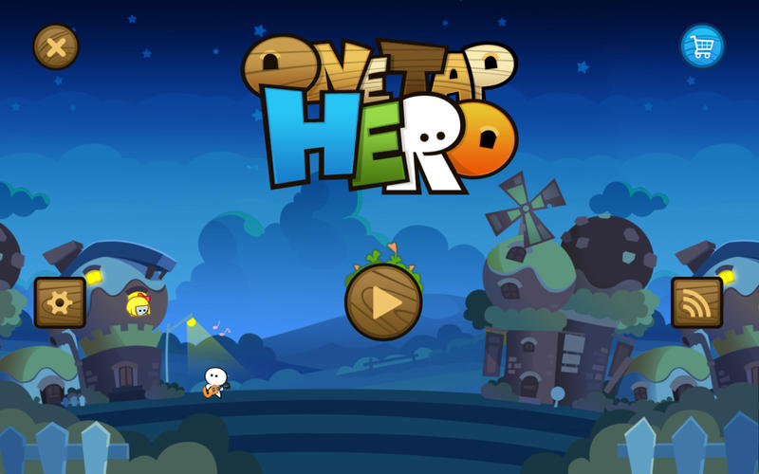

* The goal of each level presented to the player is to collect 3 stars. The player can collect no stars and still complete the level, but the more stars a player collects the higher score the player receives. This helps keep the player engaged as there is a reason to explore the level and collect all stars, so the player can gain a better high score.
* Each level has plenty of coins to collect, and the coins collected can be spent in the shop. This helps keep the player engaged as there is always something to collect and aim for.
* Some of the stars are harder to reach than others. This helps keep the game enjoyable and engaging, as the player is being rewarded by collecting the easy stars but the players skill is being tested by the harder to reach stars.
* The difficulty curve is balanced well. The first few levels begin by showing one mechanic at a time. Then as the player progresses the levels start using a combination of mechanics together for the player to overcome obstacles. This helps the player to stay engaged because the players skill is constantly being tested, especially in the late levels.
* In the later levels enemies become involved, and the player must avoid contact with them as this results in failing the level. The player instead must manipulate deadly hazard into the enemy actors, by using levers that move platforms around. This keeps the player engaged as they must overcome an obstacle which will end the level and cause a restart, forcing the playing to rethink the best strategy to use.

Leap Day



* There are plenty of fruits to collect throughout the level, with many of the fruits proving hard to reach due to obstacle being in the way. This is helping to keep the player engaged as the player must think about the best way to reach the fruit without forcing a restart. Also, this helps keep the game enjoyable as the player is always achieving something by overcoming a smaller challenge.
* There is a variety of different obstacles and enemies which can cause the player to fail the level. By including this the player is constantly being challenged to rethink the best strategy going forward and is never getting bored of facing the same obstacle.
* The developers of Leap Day upload a new level to the game every 24 hours. This helps the player to stay engaged as this provides new obstacles and challenges for the player to overcome.

Tower of Babel

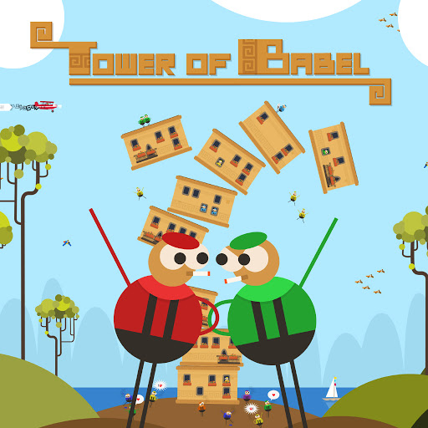

* If a player manages to land their block perfectly onto the block below them, they are rewarded with extra points. This helps keep the player engaged as they must focus on when to release the block.
* The player is rewarded with a power-up when they get a perfect landing. By doing this the player is engaged more when it’s their turn, as they will want to be rewarded.
* As the tower grows taller the players blocks become smaller. Meaning the player becomes engaged more as there’s a bigger risk of losing.
* The game introduces a wind mechanic randomly during play. This mechanic will force the players block further to the left or right depending on wind direction. The player becomes more focused and engaged because the wind makes landing the block more difficult.

Badland

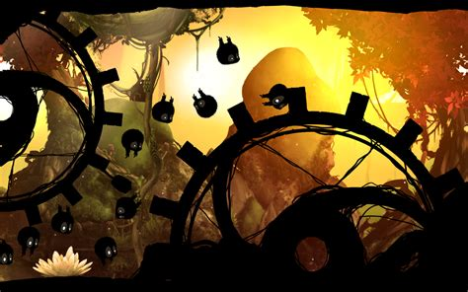

* The player controls more than one playable character at a time. By controlling more than one playable character the player must become more engaged, because control of multiple playable characters at once becomes more difficult to navigate.
* The player can pick up power-ups which allow the playable characters to grow bigger or smaller. A bigger character becomes heavier and slower, but can destroy platforms in the way. A smaller character can fit through smaller gaps in a level, gaps a normal size character could not fit through. This mechanic forces the player to engage more, because they must think about what power-ups are needed to progress further in the level. It also asks for the player to change strategy on the fly, creating more enjoyment.
* The game has various obstacles to overcome, such as falling rocks which can crush the playable character, bombs which blow up when touched and can cause the player to fall off screen, spikes that impale the playable character. All these different obstacles keep the player looking ahead and engaged with the screen.
* There are power-ups which increase the players speed forward, but also ones that slow the player down and ones which completely reverse the players movements. The game has many various power-ups which can help the player or diminish the players chances of winning. This helps player engage more with the game, because they must constantly be aware of what power-ups are in front them.
* One of the main challenges the player must face while playing, is the chasing camera. If the playable character gets caught by the back of camera and ends up off screen, then the player loses and must restart at the previous checkpoint. This forces the player into a sense of urgency, especially if the player is close to being caught. This sense of urgency helps engross the player as there’s always a constant threat of defeat.

Challenges to Incorporate into Our Game

* Lots of things for the player to collect, this helps keep the player engaged because they are always looking for ways to help improve their play. Our player could collect items which help increase their final score. Collect power-ups which helps the player increase their chances of winning. Have items which decrease the chances of the player winning, so the player is always thinking about the best strategy going forward.
* Have a balanced difficulty curve by keeping the game simple at the start, but as the player progresses increase the challenge by adding more mechanics and obstacles. This will keep the player engrossed and the game enjoyable for longer.
* Have a variety of different obstacles in the game. By doing this the player will constantly be challenged by new obstacles, forcing the player to rethink strategies.
* Reward the player when they overcome a challenge. We could do this by awarding extra points to the player, giving power-ups that increase the chances of winning, or aesthetically to show the player they have achieved something.